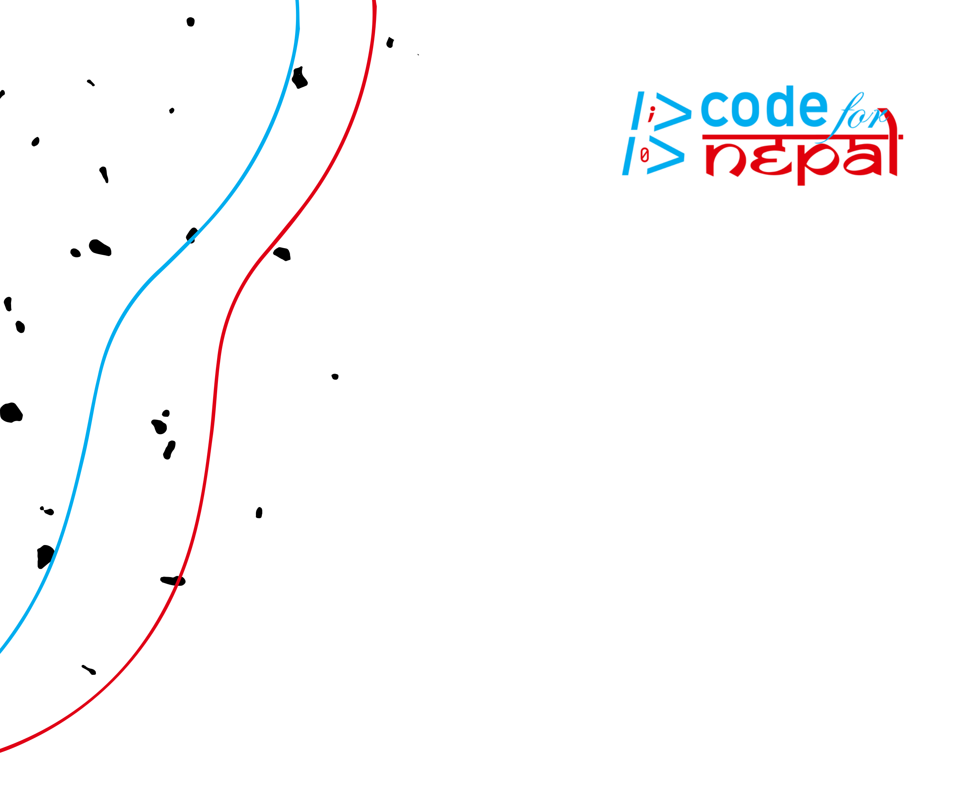

**The User's Guide to Mobile**

**YouTube:**



Navigating Through Endless



Entertainment & How to Build Your Feed

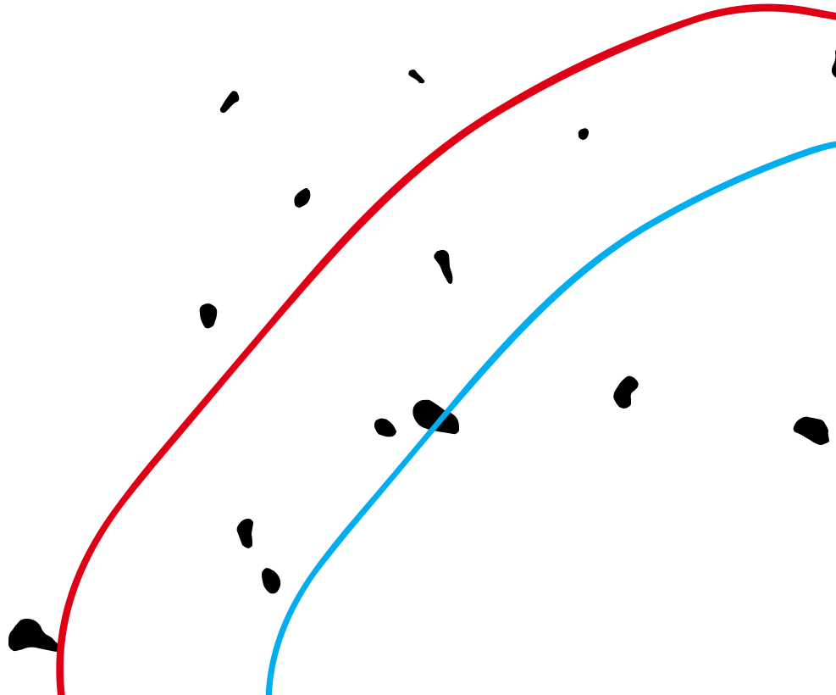

**Introduction**

YouTube is an online video-sharing platform that allows people to create and post videos publicly where other people can view, interact with, and share those videos across the internet. You can find essentially anything on YouTube, and there is a variety of content categories to choose from. However, the Entertainment category is by far the largest. This content category can help viewers to learn about different cultures and lifestyles in a way they enjoy, which makes the way they find these videos incredibly important.

This document is intended to help new and experienced YouTube users to navigate through the Entertainment content on YouTube strategically so that they can have more opportunities to find content that can entertain as well as inform them.

**Definitions**

**YouTube Algorithm** - A feature of YouTube that analyzes a users activity and tailorsvideos to that user's interests

**Channel** - A feature of an account where creators can upload and organize video content

**Creator** - An owner of a channel who produces content

**Content** - The information and experiences presented to a user

**Step One: Create an Account &**

**Learn the Layout**

In order to benefit from the YouTube algorithm, you have to sign into YouTube using a Google account. Fortunately, this process is completely free and relatively simple.

**1a.** Once you’ve signed in, you will automatically be directed to theYouTube home page, depicted in **Figure 1**. We’ll talk more about this page in step two, but for now just focus on getting familiar with the YouTube layout. Feel free to explore your account setting and details by clicking on your **profile icon**.

**1b.** At the bottom of your screen, you’ll notice a set of five buttonscalled the **menu bar**. Clicking on these buttons will direct you to different pages of YouTube. For example, clicking on the “Home” button on the far left will redirect you to the Home page no matter where you are on YouTube. We will take a look at the remainder of these buttons in the next steps.

**Profile**



**Icon**

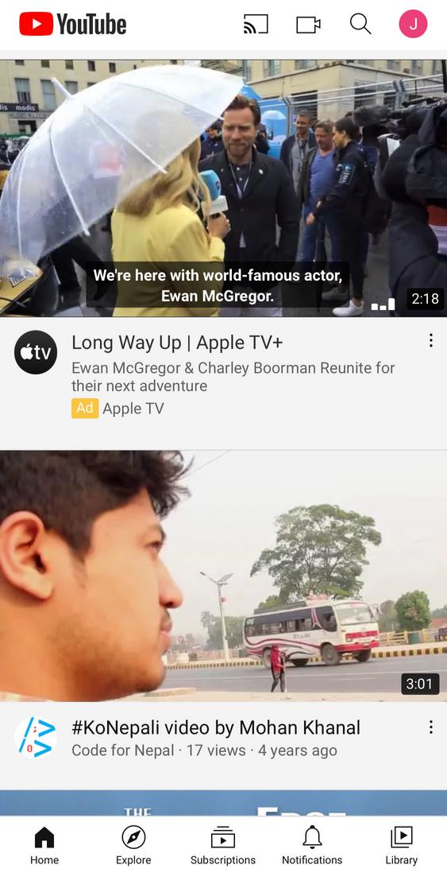

**Menu**



**Bar**

**Figure 1**

**Step Two: Start Watching Videos**

One of the most important ways the YouTube algorithm is able to learn about your interests is through your watch history, or the history of videos you’ve clicked on. Two of the easiest pages you can find content are the home page and the trending page.

**2a.** Home Page



i. The Home page is where the YouTube algorithm presents you with all the videos it thinks you’d be interested in based on the data it’s collected on you so far. YouTube calls these videos “Recommended videos.” On this page, YouTube does all the work for you, all you have to do is scroll through the page until a video catches your attention. Once you’ve found one, tap anywhere on that video and you’ll be redirected to it. Don’t worry, the five buttons on the bottom of your screen will always be there.

1. Once you’ve been redirected to the video, you’ll see even more recommended videos to the right of your screen. These videos are recommended to you based on the video you’re currently watching. If any of these videos interest you, you can tap on them to watch them. These videos don’t disappear or change unless you exit the current video you’re watching, so don’t worry if you want to finish watching before clicking on something new.

**2b.** Trending Page



i. You can find more videos by tapping on the “Explore” tab, highlighted in red at the bottom of **Figure 2**. This tab directs you to the **trending page** which shows some of the most popular videos on YouTube at the moment. This page gets updated as views fluctuate, and new videos get posted. You can also select specific **content categories** for videos you want to see at the top of thepage.

**Content**

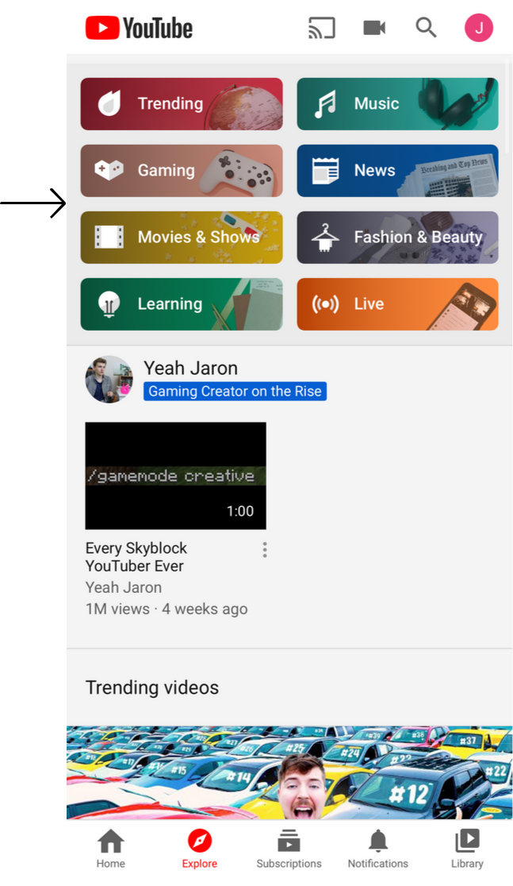

**Categories**

**Trending**



**Page**

**Figure 2**

**Step Three: Interact With Videos**

Interacting with videos can help the YouTube algorithm get a more accurate perception of the kinds of videos you like and dislike.

**3a.** Near the middle of your screen underneath the title of the video,you’ll see a set of five **buttons,** depicted in **Figure 3**.



1. The thumbs up button will allow you to “like” a video
2. The thumbs down button will allow you to “dislike” a video
3. Clicking the “Share” button allows you to share the video with others through text message, twitter, etc.
4. The “Download” button is a YouTube premium feature that allows you to download the video to your own device. YouTube Premium is a paid subscription to YouTube that offers several additional features to the platform such as ad-free videos.
5. The “Save” button allows you to add the video to a “Watch Later” playlist that you can go back to on your account to watch the video whenever you want without having to search for it

**3b.** Another very important button that matters a lot to the YouTubealgorithm is the **subscribe button**. Click this button to “follow” the channel that posted the video you’re watching if you’d like to support their channel and get notifications when they post new videos.



**3c.** Beneath the **subscribe button** there is a **commenting section** where you can write and post your comments and thoughts about the video to the public or read and interact with others’ comments.



**Subscribe**

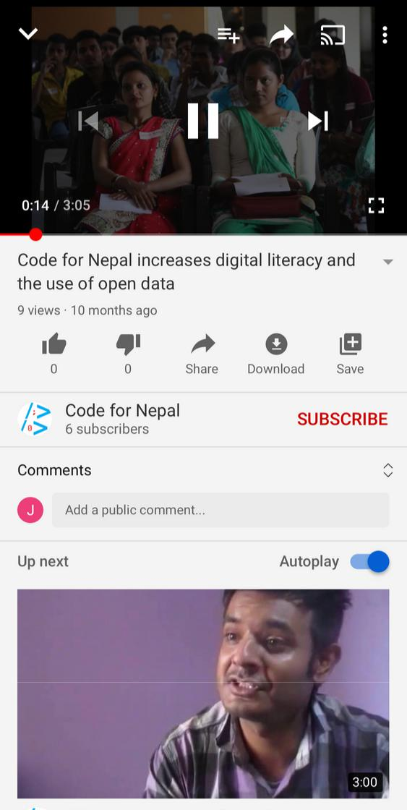

**Buttons**  **Button**



**Comment**



**Section**

**Figure 3**

**Step Four: Interact With Channels**

Just like interacting with videos, interacting with channels helps the YouTube algorithm to learn more about the kinds of creators you like and dislike .

**4a.** If you find a video you like, you can learn more about its creator byvisiting its channel. You can do this by clicking on the channel name to the left of the subscribe button. This will direct you to that channel's page.



**4b.** Once you're at the channel's page, depicted in **Figure 4,** you'll seea set of **buttons** near the top of the screen. These buttons are not always the same for every channel, but these are the most common:



i. The "Home" button will bring you to the channel's home page where you can subscribe to them by clicking the big red "Subscribe" button beneath their channel name. You'll also see a number of their most popular videos.

1. The "Videos" button will bring you to the channel's complete archive of every video they've publicly uploaded.
2. The "Playlists" button brings you to a page where the creator organizes their videos into different categories, or playlists. Clicking on a playlist will play each video within the playlist one after another.
3. The "Channels" video will show you other channels the creator uses to post videos on, and you can subscribe to them here.
4. The "About" button will direct you to a description of the channel and its content.

**Buttons**

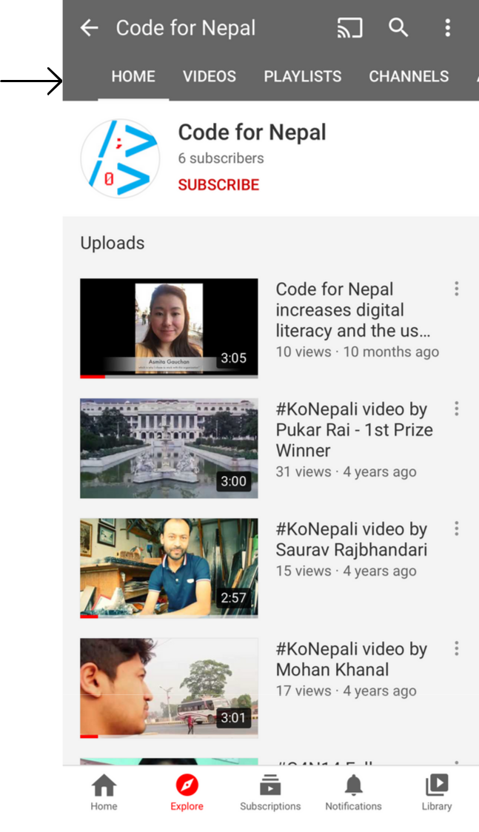

**Figure 4**

**Step Five: Utilize the Search Bar**

Just like your watch history, YouTube uses your search history to get to know you, so it's just as important to search for the content you want to see as it is to click on videos YouTube recommends to you.

**5a.** You can search for videos, channels, movies, music, etc. by clickingthe magnifying glass icon at the top right of your screen next to your profile icon.



**5b**. You can search for content by typing in the **search bar,** depicted in **Figure 5**, and using key words like "American sports" or even usingcomplete sentences like "Who is the best American soccer player?"

**5c.** You'll notice as you begin typing that YouTube makes **search suggestions** for what you're searching for, and they appear beneathyour **search bar**. If one of these suggestions matches what you're looking for, you can click on it and it'll automatically direct you to the search results.



**Search Bar**

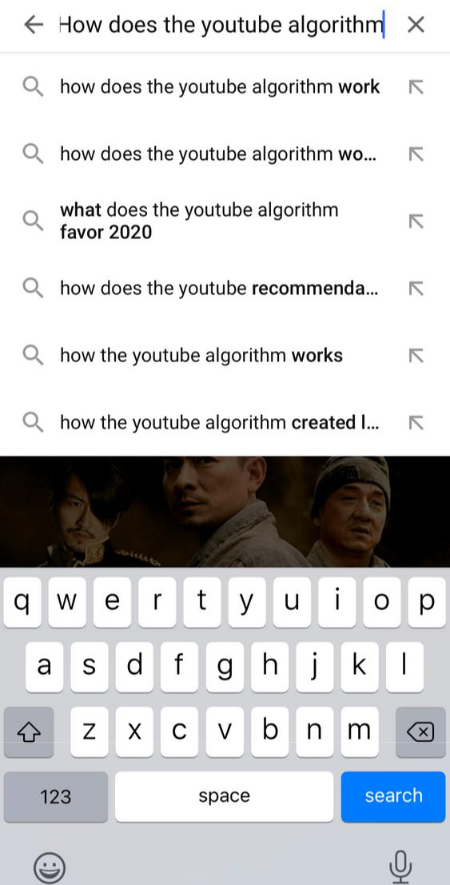

**Search**

**Suggestions**

**Figure 5**

**Step Six: Manage Your History and**

**Data**

Managing your account history is one of the most

important steps you should take in order to

optimize your impression on YouTubes algorithm and consistently find content you’re interested in with ease.

**6a.** You can access and edit your history by clicking on the "Library" tab,highlighted in red at the bottom of **Figure 6**.



**6b.** At the top of this page, you'll see your most **recently watched** videos.



Near the middle, you'll see four **buttons**.

i. The "History" button will direct you to a complete list of all of the videos you've watched on your account. You can remove videos from your watch history by clicking on the three dots icon to the right of the video and selecting "remove from watch history." Doing this essentially removes this video from the algorithm, and YouTube will be less likely to recommend similar videos to you.

1. The "Your Videos" button refers to videos you've uploaded to YouTube.
2. The "Purchases" button will bring you to a history of what you've purchased on YouTube. This includes renting a movie, for example.
3. The "Watch Later" button brings you to the list of videos you've marked as "watch later" and allows you to easily access videos you’d like to watch at some point.

**6c.** Beneath these buttons, you'll see any **playlists** you may follow or havecreated. Playlists allow you to store videos you’d like to watch again and again and put them into categories.



**Recently**

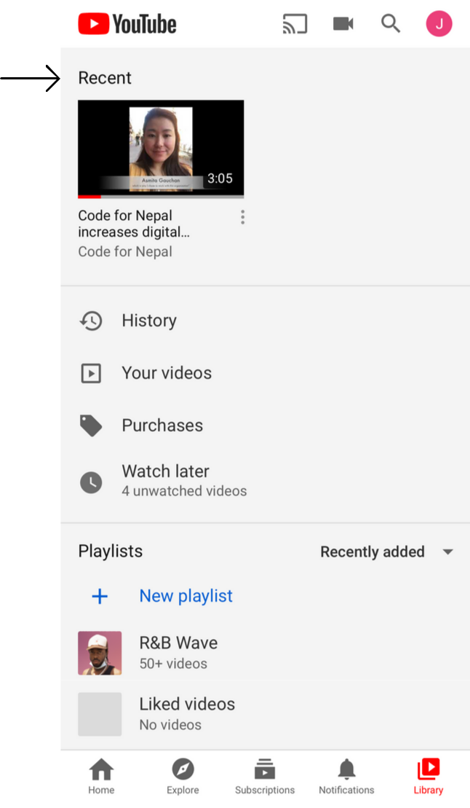

**Watched**

**Buttons**



**Playlists**



**Figure 6**

**Step Seven: Be Patient**

Lastly, another important step in building yourself the best feed for your YouTube account is using your account consistently and managing your history and data over a period of time.

**7a.** Doing all of the steps above consistently over time will enhance theYouTube algorithm to a point where you will nearly never have to look anywhere beyond the home page to find interesting and relevant content.

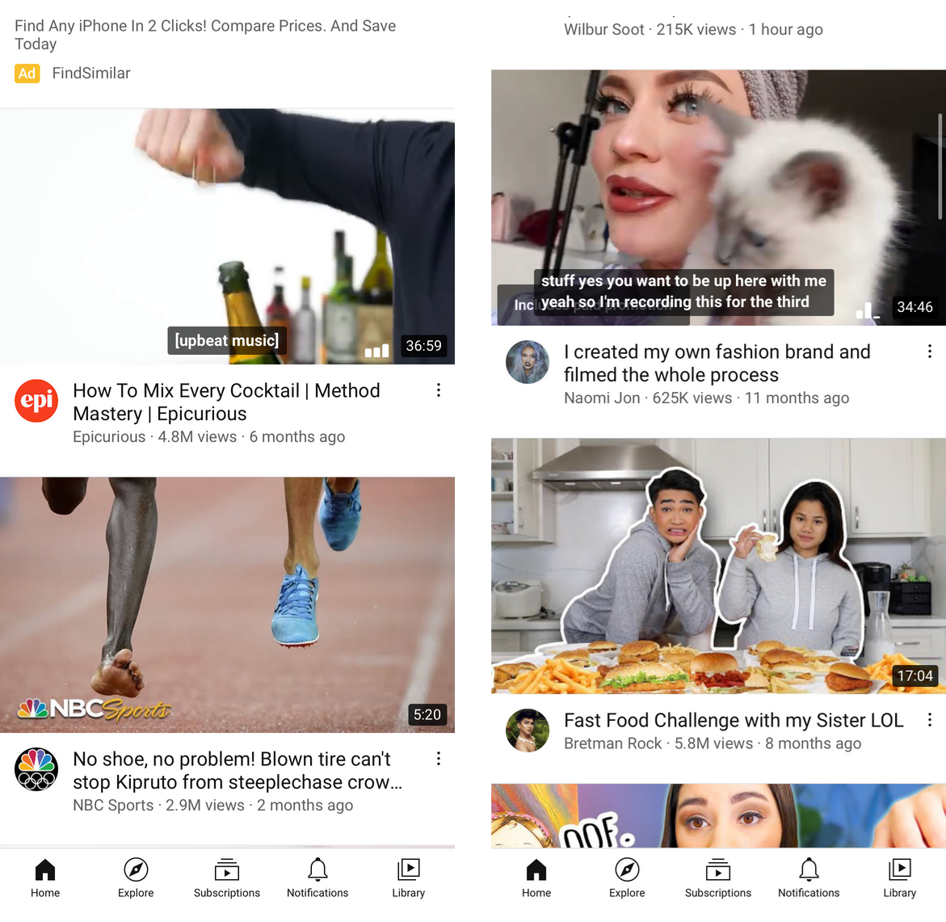

**7b.** For example, say that the two figures to the right represent thehomepages of a young person who is interested in fashion food before and after they followed the above steps.

i. Notice in **Figure 7a** that without following any of the above steps causes this person's home page to consist of mainly advertisements and videos from common news sources.

1. Notice in **Figure 7b** that after following all of the above steps, this person's home page consists of content that is specifically tailored to their personal interests.

**Figure 7a: Before** **Figure 7b: After**

**Conclusion**

Following these steps will ensure that you have access to YouTube content that is entertaining, informative, and relevant to you. Watching these videos, you may not initially recognize their significance. However, as you practice step seven and continue watching entertainment YouTube content, you will be enriched and enlightened by learning from YouTubers with diverse backgrounds and insights, and you may even join certain communities that you will be introduced to along the way. Continuing to further your digital literacy on YouTube will only enhance these benefits for you.